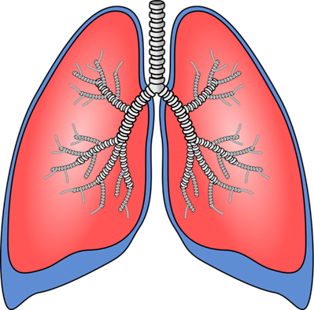

Lung
Transplant
Patient Education I
Edited 3.14.23

Introduction
This handout provides an overview of Lung Transplantation at UCSF. We’ll describe this process as if we are headed straight for transplant, but please know that it may not be that simple. For example, we may find something during the evaluation process that tells us you are not an appropriate candidate for transplant. If this happens, we will let you know of our findings so that you may follow up as appropriate with your local care providers.

Evaluation

We first start with an initial evaluation meeting in which you will at least meet with one of our pulmonologists, and may also meet with other members of the transplant team (Transplant Coordinator, Social Worker, Dietician, Financial Counselor). This initial visit gives us some idea of whether it’s appropriate to proceed with further testing and visits. You will be informed about whether we plan to proceed with evaluation or not. We will also send a letter to your local physicians to let them know our findings.
If we choose to proceed with evaluation testing, there are a large number of tests which can be broken down into four categories:

  - Tests to determine how sick you are
  - Tests to determine how well you are
  - Tests to make sure you have no current infections or malignancies
  - Tests to check out your esophagus
For lung transplants, we are looking for the “transplant window” of being sick enough to need transplant, yet well enough to recover from the large surgery and difficult post-operative period. We will also request testing to determine if you have any infectious or malignant processes going on. The reason for this is that we are looking forward to the time of transplant, when we will start medications to suppress your immune system. If you currently have a small (and maybe even unknown) infection or malignancy, when we suppress your immune system we may turn a small problem into a large problem rather quickly. The fourth category of testing involves tests to assess your esophagus and may not be required of all potential recipients.

Types of Testing During Evaluation

Below is a list of the types of testing you can expect during the evaluation process...

- Blood Tests
  - Blood Typing (ABO)
  - General Labs
  - Serologies
  - Tissue Typing
  - PSA (Men)
- PFTs
- 6 Minute Walk Test
- CT scan
- Chest X-ray
- EKG
- Echocardiogram
- Cardiac Catheterization
- Abdominal Ultrasound
- Urinalysis
- 24hour Urine Testing
- Bone Density Scan
- PPD (skin test for TB)
- Vaccinations
  - Hep A, Hep B, Tetanus, Pneumonia, Flu, COVID
- PAP smear (women)
- Mammogram (women)
- Colonoscopy (>50 yrs)
- 24hr pH/manometry
- Dental Clearance

In addition to these tests, we may need other tests specific to your medical history or to check out abnormal findings during the first round of testing. We prefer most of the testing be completed at UCSF and will try to make it convenient by stacking tests in a two or three day period, especially if you are coming from a distance. Routine maintenance testing, like your PAP smear and colonoscopy may be done locally and we will send you a list of tests that you can take care of with your local providers.

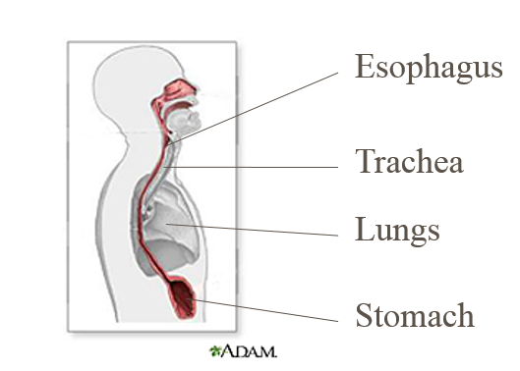
Esophageal Testing

Esophageal testing may not seem like something that we would check out for lung transplant. The reason we want to check out your esophagus (the tube that helps move food from your mouth to your stomach) is to determine if you have high risk for aspiration (which is getting food or water into the lungs). If you have significant reflux of stomach acid and contents up into the esophagus, this can get into the airway (or trachea) and down into the lungs. For a small population, severe aspiration may be contributing to their current lung problems. For those patients with diseases that put them at higher risk, we will request tests to help us assess if the aspiration will be problematic after the transplant. Our goal would be to protect the nice, new transplanted lungs as much as possible.

Evaluation Wrap-Up

After the medical tests are complete, we will schedule you for visits to assess your candidacy now that we have more information. At some point in the process, you will meet with at least one of our pulmonologists, one of our surgeons, the transplant coordinator, one of our social workers and our dietician. You may also meet with one of our financial counselors and with one of our cardiologists.

Listing

Selection Meeting

The lung transplant team has a weekly selection meeting to discuss patient cases. Once we have enough information, we will discuss your case and decide if you are a transplant candidate and if now is the right time to list you for transplant.

Consider Transplant "Window"

Again, we are looking for the window of time when you are sick enough to need transplant, yet well enough to recover from it. There are certainly risks in moving forward with transplant, including risks of the surgery, infection, rejection and life-long medications. We do not want to expose you to these risks before it’s necessary.

If Decision is to List

If the decision of the team is to list you for transplant, we will obtain authorization from your insurance and our financial counselor will contact you to discuss what will be covered by insurance and what won’t. Prior to listing you, the transplant coordinator will contact you to make sure that you are mentally and emotionally ready for listing. To put you on the UNOS list for lung transplant, your information is electronically entered into a secure website. UNOS stands for “United Network for Organ Sharing” and is the organization that oversees all transplant in the United States…including lungs, livers, kidneys, hearts, everything that gets transplanted.
Lung Composite Allocation Score (CAS)

Since 2005, donor lungs were allocated on a need and benefit basis by assigning a Lung Allocation Score from 1 to 100. This scoring system went through several updates, each time trying to make it more fair for patients on the waitlist. In March 2023, this scoring system was updated and renamed the Lung Composite Allocation Score (CAS). This allows for the Continuous Distribution of lungs and it now includes factors like sensitization, donor/recipient size match, and placement efficiency, in addition to other factors already included. The lungs are offered to patients with the highest scores first. A sub-score of your Composite Allocation Score is determined at the time your data is entered into UNOS, and revised when your information is updated. Some tests need to be updated every six months in order to keep your allocation score current. At the time of a donor offer, your specific score is determined by adding up to 10 additional points to your sub-score. These points are allocated based on the specific location of the donor hospital and our transplant center.

Here is a list of some parameters included in the lung composite allocation scoring equation...

Medical Testing

- Blood Type
- Pulmonary Artery Pressure
- Total Bilirubin
- Cardiac Index
- Pulmonary Capillary Wedge Pressure
- Serum Creatinine
Other Information

- Oxygen at Rest
- Age
- Body Mass Index
- Diagnosis
- Assisted Ventilation
- Functional Status
- 6 minute walk distance

Keep in mind that the composite allocation score is only part of the total equation, and that you’re not being ‘graded’, even though it may seem like it. UNOS puts out a pamphlet describing the lung composite allocation scoring and we will provide this to you.

What's a "Good" Score?

We often get questions regarding “what’s a GOOD score?” Essentially, the higher your score is, the more donor offers we will get on your behalf. The average sub-scores we’re seeing for outpatients who are able to wait at home for transplant, even those on oxygen is approximately 20-25. Even though this may seem like an extremely low score, we do get offers for patients in this range on a routine basis. The sub-scores we see for patients who are in the hospital and on the ventilator are between 30 and 40, and thus, those patients receive donor offers before the patients waiting at home. Keep in mind that there are up to 10 additional points added to the sub-score at the time of a specific donor offer that reflect the distance from the donor location to our transplant center.

Waiting on the List
When you are placed on the list, here are some things you’ll need to know…

We MUST be able to reach you at ALL times, so you will need to keep us up to date with any phone or address changes.
Before you are listed, you will need to make your own arrangements for getting to the hospital at the time we call you in for transplant.
There are monthly support group meetings run by our social workers which you are encouraged to attend.
We also encourage you to keep in shape as much as possible, given your breathing issues. One way to do this is to keep active in a pulmonary rehabilitation program. Your local pulmonologist can refer you to the closest one.
You should know that the time you wait on the list is very unpredictable. We have no way to know when a donor will pass away and if that donor will be compatible with you. The average wait right now on our lung list is between 4 and 7 months. However, we have had patients called in within a day of listing for transplant. We also have patients who have waited years for their transplant, based on immune system issues or low allocation scores. We will need to update your testing periodically. Some of the tests for your lung composite allocation score must be updated every 6 months. You will also need to have blood drawn periodically so that we can keep current on your antibody levels and so that we have blood in the lab to test you against potential donors for compatibility. The transplant team will want to see you periodically in clinic while you are on the wait list to make sure that we are current with your status.
You MUST update the team with ALL changes in your health, your insurance, your phone numbers and address. If you get sicker or are hospitalized locally, please call us immediately or have a family member or friend call us. We may want to consider having you transferred to UCSF in anticipation of urgent transplant. Unfortunately, we have no way to know of these developments if you (or your family) don’t call us.
If new issues develop, your candidacy will be re-assessed and if you are no longer a candidate, you will be removed from the list. You will be informed of any changes in your candidacy.
The “Right” Donor

Unfortunately, there is no way to predict when the right lungs will be offered for you. The lungs come from a person who has passed away and their family decides to donate the organs. Though your name is put on a national waitlist, most of our donors come from Northern California for timing reasons.
In order for a donor to be the “right” donor for you, the donor must have a compatible blood type to yours. This is because your immune system would immediately recognize and attack lungs from an incompatible donor. Prior to listing, we test your blood for your genetic markers deemed important to transplant. We also test your blood for antibodies that might be significant in transplant. Antibodies are part of our immune system that recognizes foreign things. They circulate through our blood system and if they recognize something foreign, they send out the signal to the rest of the immune "army" to "ATTACK!" If you have a high level of these antibodies, it may take us longer to find the right donor for you.
The lungs must be a compatible size to what your rib cage will hold. Very small lungs won’t be enough to sustain you…and though it sounds like bigger should be better, the lungs will be put into a confined space. If they can’t fully expand, you won’t be able to get full use of the lungs. It also means that you would be at increased risk for technical complications and infections.
The third thing considered in finding the right donor is the Lung Composite Allocation Score. The lungs are offered to the patients listed with the highest scores first.
We MUST be able to reach you when the right offer comes available since we’re not sure how long it will take to get another appropriate offer. If we cannot contact you within a short period of time, the offer will go to the next person on the list.

Being Called in for Transplant

When we get the call the “right” lung or lungs for you, we will call and let you know that we need for you to come to the hospital right away. When we call you in, all the information we have indicates that these are the right lungs for you, but at the time we call you, the lungs have not been taken out of the donor yet. The reason we call you in prior to the organ retrieval, is that we want to keep the ischemic time (the time that the lungs are out of the body, either the donor’s or the recipient’s) as short as possible. This is the reason that most of our lung donors come from Northern California, even though UNOS is a national list.
If we find a problem with the donor lungs as they are being retrieved, like maybe the anatomy is very complicated and it would be difficult to hook up in you, or that there was a cancer in the lungs, or that they were damaged during the retrieval surgery, we will send you home without transplant. We are looking for the most pristine lungs to start with since there are already enough risks in this process. It may happen as often as 1 out of every 3 or 4 times that we call in a patient who is sent home without transplant. If this should happen to you, nothing is lost in the process. Your lung composite allocation score is unaffected and you will be called back in as soon as we get the next offer for the right donor lungs for you. It’s not as though you have worked your way to the top of the list and now have to start at the bottom again.
When we call you in, we will instruct you on where to check in at the hospital and give you any special instructions.
Once checked in, we will get IV’s started, draw some blood, get chest x-ray and EKG and any other pre-operative tests we may need.

Surgery

Single Lung, Bilateral Lung,
Or Heart-Lung
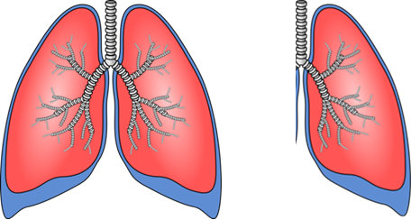
We can transplant either a single lung or bilateral lungs (meaning both). You should be prepared to be called in for either one or two lungs, unless we have specifically told you otherwise. There are reasons which require both lungs be transplanted, like pulmonary hypertension and chronic active lung infections. And there are three general reasons we would choose to transplant a single lung instead of two:
vs.

- Age. In the population over 60 years old, there is no distinct advantage in transplanting two lungs over transplanting one…and since the surgical risk is higher for the bilateral transplant, why would we put you at increased risk without increased benefit?!
- Anatomy or history. If the recipient’s anatomy or history prohibits bilateral transplant, we will consider only transplanting one lung. For instance, if there is scarring of the lung tissue to the chest wall where we cannot get the old lung out to put the new one in, we may need to consider single lung transplant on the opposite side.
- Timing. Thirdly…. Timing. Let’s say that a patient is on the list and their score is low and the anticipated wait time would be very long for two lungs, but a good single lung comes available. This is to the patient’s advantage. Or let’s say that while on the waitlist, a recipient’s lung disease gets much worse, they’re hospitalized and on the ventilator, and they need transplant very soon or they may expire. Even though the original plan may have been for two lungs, now things have changed dramatically, and at this point, one lung may be better than none.

In the rare instance that you would need both a heart and lung transplant, this would be known well in advance and discussed with you.

Incision

The most common incision for putting in two lungs is called a clamshell incision. The incision goes from under one arm to under the other arm, across your chest, and comes up about two inches in the middle. The incision is opened top to bottom, not side to side.
If someone has had previous cardiac surgery where they already have an incision down their chest through their sternum, the surgeon will likely go through the scar and open the chest side to side.
If only one lung is being transplanted, the incision will be low over the side of the ribcage on the side of the transplanted lung.

Surgery Length

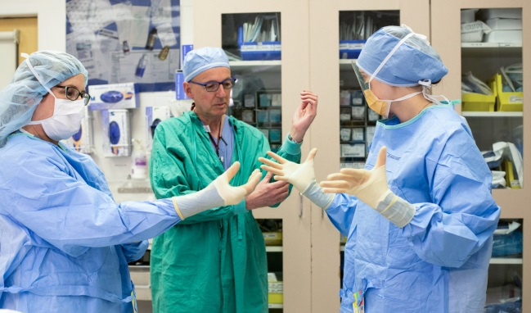
The average surgery is about 8 to 10 hours long and you are completely asleep for the surgery.

Surgical Risk

The surgical risks of transplant are the same as the risks for any general anesthesia surgery. There is a risk of infection, a risk of blood clots, risk of bleeding, risk that you may react to the drugs that they give to put you to sleep and there is a small, but real, risk of death.

Immunosuppression

During the transplant surgery we will start you on medication to suppress your immune system. This is due to the nature of the donor genetics and the recipient’s immune system.
The normal job of our immune system is to scan the body, recognize “foreign” things, attack them and get rid of them. Unfortunately, the immune system can’t tell the difference between “good” foreign (like these nice new pretty lungs) and “bad” foreign (like a virus). It only sees “foreign” or not “self”.
The donor’s lungs have genetic markers on them that identify them as donor. All of the donor’s organs and cells have markers on them that say “Donor”, for simplicity’s sake. When the lungs are donated to the recipient, the recipient’s immune system finds these “Donor” markers, since they are not “self”, and sends out the message to the rest of the immune ‘army’ to attack the lungs.
This act of the immune system attacking the transplanted organ is known as “REJECTION”.
Because the genetic markers on the transplanted lungs never change, and because the immune system’s job continues to be finding and getting rid of foreign things, you will need to take the immunosuppressive drugs life-long. Other drugs will come and go, but the three immunosuppressive drugs are life-long.

Hospitalization

Once the surgery is over, you will wake up in the Intensive Care Unit (ICU) on the 6th or 10th floor of the hospital at 505 Parnassus Ave, San Francisco. When you wake up, you will have lots of things attached to you that you didn’t have when you went to sleep. You will have a tube in your throat which is connected to the ventilator. Be assured that this tube does not mean that the transplant failed. We need you awake and able to follow some commands to know that the lungs are working well. It’s much easier to wait a few hours and make sure that the lungs are working well, then take the tube out, than to take it out too early, and risk having to put it back in again. It’s much more traumatic to have to put it back in. You will have IV’s in your neck or shoulder area that you didn’t have before you went to sleep. You will have the incision, with the skin closed by surgical glue or stitches across your chest or side. Initially, this incision will be covered with gauze and a cellophane dressing to catch any drainage. The bandaging will come off in a day or two. You will have somewhere between two and four “chest tubes”. These are tubes about as large around as your finger, and they are connected to containers at the bedside to collect any drainage from the incision. We don’t want fluid to collect in your chest or abdomen because of the risk for infection. The chest tubes will come out after the drainage has stopped, typically after several days. You will also have a catheter in your bladder which will be connected to a drainage bag at bedside to collect urine. This will usually be taken out once you are up and able to get back and forth to the toilet or commode. Though the surgeons do some nerve freezing (or cryoablation) during the surgery to manage your pain, you may need an epidural catheter in your back for pain management. This would be removed once your pain is well managed by oral medications. You are likely to be on blood thinners to help prevent blood clots from forming while you are bed bound and you may require insulin injections to help control your blood sugar level.
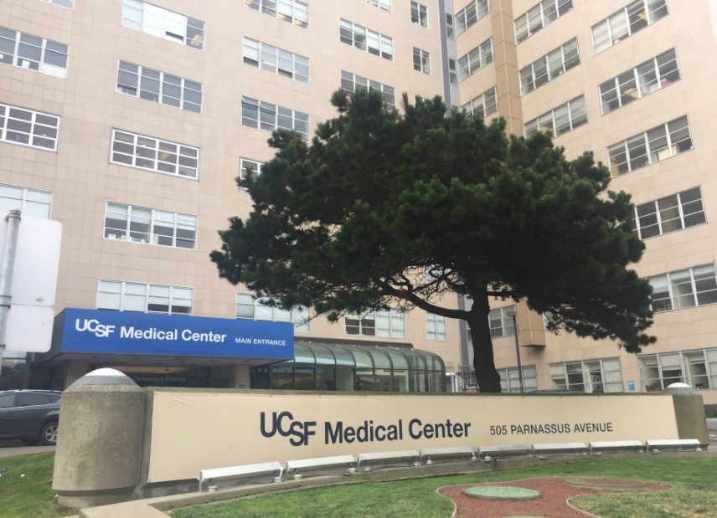
After transplant, IF you have significant reflux disease or esophageal dysfunction, you may need a feeding tube placed into the intestine to bypass the stomach and esophagus for a period of time, maybe even permanently. This will prevent the new lungs from being damaged by the stomach contents. This means that you will not eat anything by mouth during this time period.

Bronchoscopy
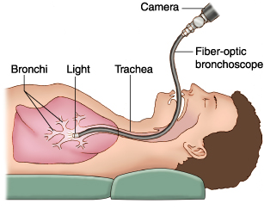
There is a procedure you will become very familiar with called a bronchoscopy. A bronchoscopy is a procedure where they use a catheter with a camera (and perhaps other equipment) attached to it to go down into the main airways and take a look around. While the endotracheal tube (breathing tube) is in your mouth, they will put the camera through this tube. After the breathing tube has come out, the bronchoscope will be inserted through your mouth.
For the first five days after the transplant, they will do this to clean out any secretions or blood that may be present in the lungs and to make sure that the suture (stitching) lines look good. These “clean-out” bronchoscopies must be done when you have an empty stomach to decrease the risk of aspiration into the lungs so you will not be given anything to eat or drink for several hours before the procedure (usually nothing after midnight). You will also not be given anything to eat or drink for a while after the procedure. These early “clean-out” bronchoscopies are rather uncomfortable as we want you to cough up any secretions deep in the lungs so that they can be suctioned out by the catheter. For this reason, the sedation must be kept to a minimum. The doctors may take some secretions to send to the lab for cultures to see if any ‘germs’ are growing that require treatment.
You will be scheduled for “surveillance” bronchoscopies at specific intervals after transplant (usually 2 weeks, 4 weeks, 8 weeks, 12 weeks, 6 months, 1 year, 18 months and 24 months after transplant). These “surveillance” bronchoscopies are used to see how the lung tissue looks and to obtain a small tissue sample from the lungs called a “biopsy”. This tissue will be sent to the lab so that it can be examined for signs of rejection. The surveillance bronchoscopies are done as an outpatient procedure. You must be fasting and you MUST have a driver to take you home after the procedure as they frequently use sedation to make the procedure more comfortable.

Hospitalization: Days after Transplant

Getting out of Bed

We will get you up and out of bed within one day after surgery so be prepared to work hard. We want you up for a couple reasons, one is to let those nice new lungs expand fully while you’re upright. The second is to try to minimize your risk for blood clots. When you’re lying down and the leg muscles aren’t moving and helping to pump the blood back to your heart, the stagnant blood may form clots. In your arms and legs, these clots are known as deep venous thrombosis or DVTs. If part of one of these clots break off, it can travel to your head causing a stroke, to your heart causing a heart attack, or to these nice new pretty lungs causing a pulmonary embolism. We don’t want any complications that we can prevent, and we certainly don’t want any damage to the lungs, your head or your heart.

Pain Management

The first few days will be a bit uncomfortable. We will walk a fine line with pain management. We will try to keep you comfortable by using nerve freezing during the surgery (cryoablation), IV or oral medications. Most drugs given for pain control are narcotics. Unfortunately, narcotics can knock down your drive to breathe and make you too drowsy to get up and out of bed. We can’t have you overly sedated since we’re trying to minimize your risk for complications.

Emotions

During the first week or so after transplant, your emotions may feel out of control, you may be sleep deprived, and you may experience hallucinations. These are side effects of the medications and the stimulating environment of the hospital equipment and staff. You may want to let your family know that this is all to be expected and a normal part of the recovery process.

Average Hospitalization

The average ICU stay is about a week, barring complications. The total hospital stay is about two weeks, barring complications.

Medications

During your hospital stay we will educate you on the medications you’ll be taking and how to care for your new lungs. The list of medications may be as long as 20 different meds or more. Most medications will be taken orally, but some are taken by inhaling them, while others require injection. Many of these will be used temporarily, and the list will get shorter over time, but you will ALWAYS have at least the two or three immunosuppressive medications for the rest of your life.

After Hospitalization

First 6 Weeks:
Staying in Close Proximity

For the first six weeks after you are discharged from the hospital, you will need to stay within 30 minutes of UCSF. If your home is further than a few hours drive, we will require longer than 6 weeks before you return to home. The reason for the required local stay is two-fold.

- Safety. The first is a matter of safety. If you’re at home, and have an emergency situation, like shortness of breath or the incision opening up and you go to the local emergency room…they don’t do lung transplant and they don’t know immunosuppression. If you’re able to get back to us, you’re in a much safer situation in the early days while you’re learning about your transplant.
- Convenience. The second reason we require that you stay locally, is a matter of convenience. Your visits to UCSF will be numerous in the first few weeks. For this period of intense follow up, you will be at the hospital or clinic for some part of most working days and if you were not staying close, you’d be on the road all the time.

First 6 Weeks:

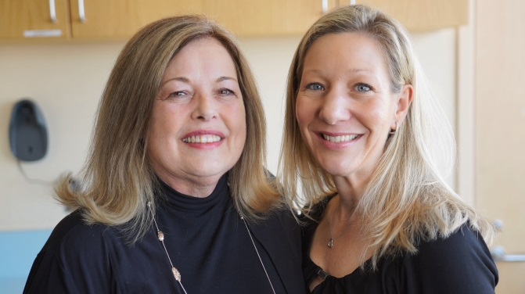
Support Person/Caregiver

During this first six weeks after discharge from the hospital, you will need a support person (or caregiver) who can stay with you for 24 hours a day, 7 days a week. This will need to be someone who is emotionally connected with you, like a friend or family member. You will also need a secondary (or back-up) caregiver in case something happens to the primary. The support person won’t be asked to do intense nursing tasks, like extensive dressing changes or starting IVs. The reason for having a support person is that you will have restrictions on lifting and on driving for at least the first 6 weeks. With all that you’ve been through, it’ll also be good to have someone who can help be an extra set of eyes and ears. You will have been through a large surgery, a large recovery, will have a long list of medications with at least two names each, will have adjustments to doses of medications, and will have numerous appointments. It’s a lot to have thrown at you all at once.

After 6 Weeks

As time goes on, the visits and follow-up testing will become less frequent and some of the testing may be coordinated with your local doctors. Though the most intense recovery period is behind you, you will still need periodic help from your caregivers (transportation to the hospital or clinic, rides home from bronchoscopies and general care when you are not feeling well).

Life with Transplant

Life-long Immunosuppression

Indeed, the immunosuppressive medications will be needed for the rest of your life. The doses of these drugs will be highest in the beginning. The reason for the larger doses is because we’ll need to knock down your competent immune system in order to let the lungs have a chance to get in and not immediately be attacked. We wean the doses of the drugs down over time, so that, ultimately, you’re on a lower maintenance dose. This is particularly true of the steroids. Other immunosuppressive drugs are adjusted based on their level in your blood.

Complicated Follow-up Regimen

Though you will be able to leave the hospital in a relatively short period of time (and we want you out, because there are infected people in hospitals and we don’t want you catching whatever they’ve got), you will still need intensive follow up. You will come for labs a couple times each week, CT scans, pulmonary function tests, visits with the pulmonologist, the nurse and the pharmacist, and you will have bronchoscopies (where they look down into the lungs with a camera, and maybe take a tissue sample for biopsy while they’re down there). This follow up will become less frequent over time, but you will always come to see us at least once a year, even if everything is going fabulously.

Early Risks after Transplant

There are two early risks after transplant: Infection and Rejection. These are the most prominent over the first six months to a year after transplant. However, these are lifelong risks, which lessen over time.

Infection

The increased risk of infection comes from your immune system being suppressed. Unfortunately, we have not found a way to suppress JUST the part of the immune system that attacks the lungs, so your whole immune system will be suppressed. For this reason, you will be more susceptible to all kinds of infection, not just respiratory ones. We may initially have you on drugs to prevent viral, bacterial and fungal infections during this period while you’re most vulnerable.
While you’re in the hospital, we’ll remind you of a number of ways that you can minimize your risk for infections. The best thing you can do is to WASH YOUR HANDS, wash your hands, wash your hands. Other precautions include care in handling foods and avoiding people you know are sick. We will also recommend that you wear a mask while visiting the hospital and clinic and that you avoid working with soil (like gardening or potting plants), among other things.

Rejection

The other early risk post-transplant is rejection. Rejection is the act of the immune system attacking the transplanted lungs. Left untreated, rejection will eventually lead to enough lung damage that they will fail. It’s not a matter of IF they fail, but WHEN.

You have two jobs in preventing rejection…

- Medications. You MUST take your medications as prescribed, when prescribed, no ifs, ands or buts.
- You MUST notify us when you experience any deviations from your “normals”. Some of this is very objective. We will have you take your vital signs twice a day and your weight once a day. We will give you parameters on when to call us and that’s all very objective. HOWEVER, you will need to call us with more subjective deviations from normal too. Let’s say that you’re running around and feeling good, then one day you’re extremely tired. You have done nothing which should have exhausted you. You have not been around someone who is sick, so you’re not getting that pre-sicky kind of tired…but you’re exhausted. This might be your only sign for rejection or infection. Let’s say that you ignore it the first day, thinking, “oh, this’ll go away, I’m just tired”, and then the second day, ignore it again…after this goes on for three or four days, it’s possible that you already have three or four days of significant damage to the new lungs from rejection. You will have less healthy lung tissue after the incident, than what you had before. You MUST call immediately with deviations from your normals. The worst that can come from this is that you call and we are able to share some information with you about whether this is transplant related or not, and how to monitor it. This way you’re building your encyclopedia of transplant knowledge for the future and eventually you become the expert.

Side Effects of Medications
There are numerous side effects of the medications that you’ll take after transplant. You may experience a FEW of these or ALL of them. It is important to report any new symptoms you’re having (even though they may be a known side effect of the medications) so that we can try to help minimize them. Some of the most common side effects that patients report are: hair loss, hand tremors, nausea or upset stomach, puffy appearing face, bruising easily, weight gain or weight loss, headaches, problems sleeping, trouble concentrating and muscle weakness.

Late Risks after Lung Transplant

There are long term risks that may not show up in the first year, or maybe the first two…but will show up after a number of years.

Drug Related Issues

Some long-term risks include diabetes (high blood sugars), hypertension (high blood pressure) and osteoporosis (decreased bone strength), which are common side-effects of the immunosuppressive medications, and often require medical treatment.

Malignancies

One of the most common long-term risks is a higher incidence of cancer than the rest of the population, especially skin cancers. This is due to the immunosuppressive medications making your skin more susceptible to sun damage. You will need to protect yourself from the sun by wearing sunscreen daily, and if you know you’re going to be out in the sun, wear hats, long sleeves, and long pants. You will also need to be screened for skin cancers. About two or three months after the transplant (after the dust settles a bit), you will need to go see a dermatologist to get a head-to-toe baseline assessment. Then you’ll need to go back to the dermatologist IMMEDIATELY when you notice changes AND at least once a year. If caught early, most skin cancers can be removed (even in the dermatologist’s office) with little problem, but if skin cancer goes undetected or untreated, it becomes very metastatic and can invade the rest of your body and become quite deadly.

Current Survival Statistics

Current survival statistics after lung transplant are more encouraging now than ever in the past. At one year after transplant, more than 95% of the patients are surviving at our center. Survival statistics are calculated every six months and are available for you to view on the Scientific Registry of Transplant Recipients website (SRTR.org).
We are always working to improve the survival statistics and believe that they will continue to get better over time.
Here are a few things you may want to consider when thinking about these numbers…

Thoughts on Survival

Some things to consider when reviewing transplant statistics are age and disease. Typically, younger patients, more fit patients, and patients who have disease that is isolated to the lungs, tend to do better with transplant.
If you compare lung transplant statistics to other types of transplant statistics, it’s a bit like comparing apples and oranges. Although lung transplant survival now approaches Kidney and Liver transplant survival at the one-year mark, our long-term survival is not quite as high. Kidney transplant had been around for almost 40 years before lung transplant became a successful option. The long-term survival statistics for lung patients are also harder to come by as it’s a much smaller population.
There is no replacement therapy for lung patients like dialysis is for kidney patients, and we know it’s harder to stay in good shape when you can’t breathe well. The lung is also the only transplanted organ that’s constantly exposed to the environment. Hearts, livers, kidneys, and pancreas all go in and get stitched shut. They’re only exposed to whatever comes by in the blood stream. But the lungs are exposed to the external environment with every breath we breathe.
Lung transplant patients are sicker to start with than patients who receive other types of transplants. For someone to be listed for transplant, we expect that their anticipated survival without transplant is between one and two years. I know this seems an odd way to think of this, but if current survival at 3 years is 85 percent, this would actually be an 85% improvement in survival over what we would have expected in this patient group.

Contact Us

We appreciate the time you’ve spent learning more about lung transplant at UCSF. You may contact our office at (415) 353-4145 for questions, comments or more information. You may also find more information at LungTransplantEducation.UCSF.edu.

