

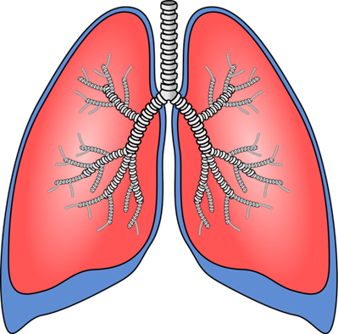

Lung

Transplant Patient

Education II



Introduction

Welcome to the second education session for Lung Transplant at UCSF. This session is focused on the information you will need to know around the time of listing, while you are on the list and also to start you thinking about the surgery, the hospital stay AND your recovery. Please review this as many times as you like and share it with your friends and family. This information is mostly about the normal case scenarios, but know that Lung Transplant is not a simple undertaking and your particular situation may be much different from this. Do not hesitate to contact your coordinator with any questions you may have. We will be happy to address your concerns and questions.

Pre-Listing

We’ll start with the information you’ll need for when your name is placed on the waitlist. When our team has reviewed all of the testing and information about your case and find you to be an acceptable candidate for transplant at UCSF, this is when we consider listing. Your name is placed on the UNOS list, which is the national waitlist, but indeed most of our donors come from Northern California for logistical reasons.

Inform Us of Any Changes

At the time you’re listed, we start to receive donor offers on your behalf, so UNLESS we receive updates from you, we will assume you are in the same condition you were when we last saw you.

We field donors offers 24 hours a day and 7 days a week so we MUST have your updated information in REAL TIME. We rely on YOU to keep us updated on ANY and ALL changes in your status.

* **Phone number changes.** Changes in phone numbers or address should be reported right away as it affects our ability to reach you when we’ve located the ‘right’ donor for you. If we cannot reach you, it may jeopardize your chances for transplant. Clearly, if we cannot find you, we cannot transplant you.
* **Insurance Changes.** If your insurance changes, please notify us right away as we want to try and make sure that you do not have unexpected financial issues while you should be focused on your recovery.
* **Health Condition Changes.** It is ESPECIALLY important to report any changes in your health condition IMMEDIATELY. Even if you have not been to see the doctor yet, call our office to report new symptoms, like runny nose, congestion, and fever right away. This will help us get the information to our call team as soon as possible. Ideally, we would like you to call and report new symptoms, then get into the doctor right away to get it checked out. You should not wait to go to the doctor, because if there is anything they can do to help shorten the illness, it will help us to get you back into active consideration for transplant. We cannot transplant you while you have an active infection, as there are already enough variables in transplant without starting like that. After you have been to the doctor, then call our office back and let us know what their plan is and if they have started any new medications, like antibiotics. We will pass this along to the call team as well. You will then want to call and update us every couple days or so with how you are doing so that we know when you’re getting back to your baseline.
* 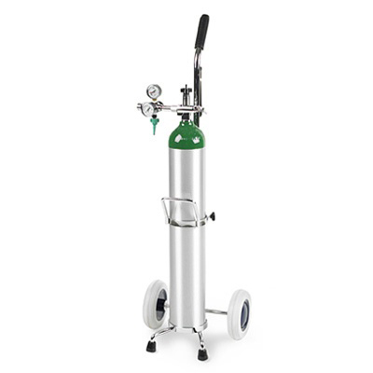**Oxygen use changes.** You will need to report changes in your oxygen use…EVEN IF YOUR USE GOES UP BY JUST ONE LITER PER MINUTE. This lets us know that you’re getting sicker and it also gets entered into the Lung Allocation Score and may move your name further up the waiting list.
* **Other changes.** You will also want to report things to us that don’t seem lung related at all….like a broken toe or a mole you have removed at the doctor’s office. The broken toe may affect your ability to get up out of bed and start your rehabilitation and, we would want to see the pathology report from the mole to make sure that it was not a skin cancer.

DO NOT rely on communication to get to us from your local doctor or hospital as sometimes they get busy with other things. Call us yourself or have your family or friends call.

We have established a 24 hour phone line, **(415) 353-4145**, especially for listed patients to call and report updates. During business hours, this is answered by our office staff, but in the off hours, it’s answered by our answering service. You will need to let the service know that you are a LISTED patient and that you need to get a message to the Lung Transplant DOCTOR on call to report your issue. This ensures that your updates get to the right person quickly.

There is a lot of choreography that goes on behind the scenes when lungs are allocated. It could happen that we call you in, find out you have new symptoms that you did not report, and then have to see if the lungs can be offered to the next person on the list. If there is limited time until the donor OR, and all the other organ teams are already in transit, we may not be allowed more time to get another recipient into the hospital from home. If this happens, there is a chance that a perfectly good set of lungs could go into the trash… and no one wants that. If you cannot use them, the next person certainly could, and this resource is far too scarce to waste.

If you do NOT call with updates, you may jeopardize your chances for transplant.

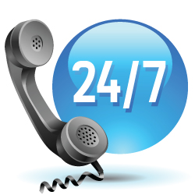Phone Availability

Next, from the time your name goes onto the list, you MUST be available via phone at ALL times. This includes days, nights, weekends and holidays as we get offers all the time, not just working hours. Your coordinator will request a list of phone numbers from you so that we can reach you all the time. If these change, don’t forget to notify us. One of the worst scenarios we can think of is not being able to reach you when we get the ‘right’ lungs and the offer passing you by. We just never know when or IF the right offer will come again. Remember to keep your phone on, the ringer up, and keep it charged.

You will need to get into the habit of answering ALL the calls that come in. During working hours, ‘The Call’ may come from our office, but the call MAY also come from a call service we use. Their coordinators are located all over the country, so it may come from an unfamiliar area code. You MUST answer all calls. When we do locate the ‘right’ lungs for you, we will call all of the numbers you’ve given us and we’ll leave messages to call us back RIGHT AWAY.

When donor lungs are offered from an Organ Bank, we have a limited amount of time to locate you, sometimes as little as an hour. This is NOT the time to get you into the hospital, but an hour to LOCATE you and see how you’re doing and make a decision on accepting the offer on your behalf or not. If we are unable to find you quickly, there is a good chance that they will pass you by for the offer, then move on down the list to the next recipient. We don’t want you to miss out on an offer and we CERTAINLY don’t want any lungs going to waste.

Keep Yourself in Good Condition

Since we don’t know how long it will take to find the ‘right’ lungs for you, here are some things you’ll need to know for the time you are waiting on the list.

In addition to calling us with ANY and ALL updates, which cannot be stressed enough, you will also want to keep yourself in good condition.



* **Keep your weight appropriate.** Don’t gain too much or lose too much weight unless you have been specifically instructed by the transplant team to do so.
* **Keep active.** The better condition you are in when you go into transplant, the better you will do with your recovery. It’s particularly important to keep your leg muscles strong so that you can get up out of bed soon after surgery and start moving around. This will help minimize complications like blood clots.
* **Stay away from sick people.** When you’re exposed to illnesses, you may develop them and you really don’t need an acute illness on top of the chronic lung issues you already have. When you develop an infection, we are unlikely to transplant you during that time. If we suppress your immune system when you have an active infection, we take away your ability to fight off the germs and it may get worse instead of getting better.
* **Practice infection control.** Wash your hands frequently and use alcohol gel if soap and water are not available.
* **Use oxygen as prescribed.** There is ABSOLUTELY no advantage in you being stingy with your oxygen use. Unless you have been instructed otherwise by our doctors, we recommend that you keep your oxygen saturations above 90%. This means that you must monitor it periodically with a pulse oximeter, so, it’s good for you to get your own. It also means that you should use as much oxygen as it takes to maintain these saturations. You may need to speak with your doctors to get the prescription adjusted so that you have adequate tanks or equipment. PLEASE do not be stingy with your oxygen use! It does your body ABSOLUTELY no good in the tanks.

Maintain Care with Regular Doctors

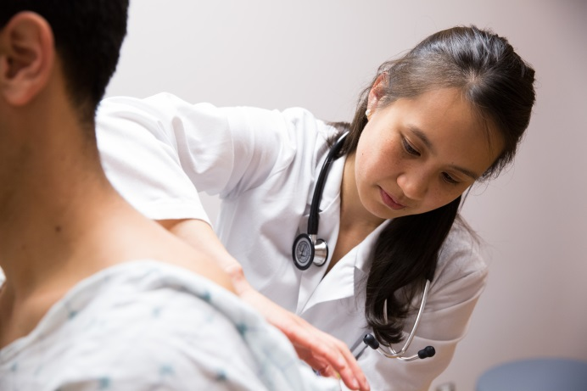While you are on the list, you will need to keep seeing your regular doctors as they are the ones who are actively treating you. We are only acting as a consult service. If you get sick, it will be your regular primary care doctor or pulmonologist you go to for treatment (but don’t forget to call us with an update). At the time of transplant, we take over your care for a while and then wean you back to your local doctors over time (except for the care of the lungs). But for now, you need for them to continue to care for you while you wait.

It is also important to maintain a good relationship with your local doctor for care after transplant. A good local doctor can help manage some of the common side effects of the immunosuppressants, like hypertension (high blood pressure) or diabetes (high blood sugars). This will allow us to focus on the care of the lungs.

Periodic Visits

To the Lung Transplant Clinic

During your wait on the list, we will want to see you back in clinic periodically to make sure that you are as good a candidate as you were when we saw you last. Typically, we see patients in clinic AT LEAST every three months. But we’ll see you more often if you get sicker or if you have hospitalizations or illnesses.

* We will need to update some of your testing (at least every 6 months) to keep the Lung Allocation Score up to date, (like breathing tests, arterial blood gases, 6 minute walk test and labs).
* We will need to get an updated CT scan of your chest at least every 6 months to screen for cancers.
* We will also need an updated Echocardiogram at least every 6 months to make sure that the right side of the heart is holding up under the additional stress of the lung disease. We will try to coordinate these tests for when you are coming to UCSF for a visit with our doctors.

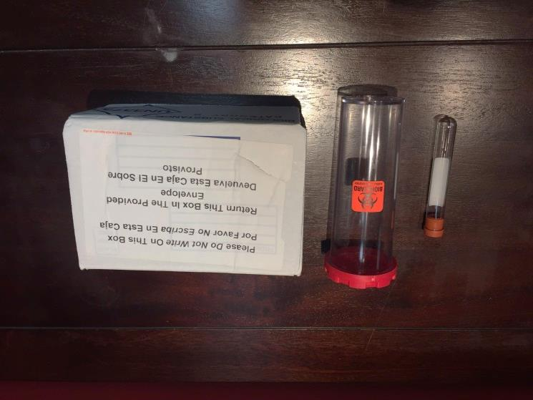Around the time you go onto the list, you will start to receive a kit in the mail every month that contains empty tubes. These are to be taken to your local lab for blood draw and are due back to our lab by the time stated in the letter that comes with the tubes. This blood will be used to re-test for antibodies against potential donors. We initially tested your blood for antibodies when you had blood drawn at UCSF, but your antibody testing can change over time. This monthly kit is our way of making sure that we know what your current immune status is. The blood may also be used to test against possible donors if there is some question of your compatibility with them. If your local lab needs an order for a standing blood draw, please contact your coordinator to get this.

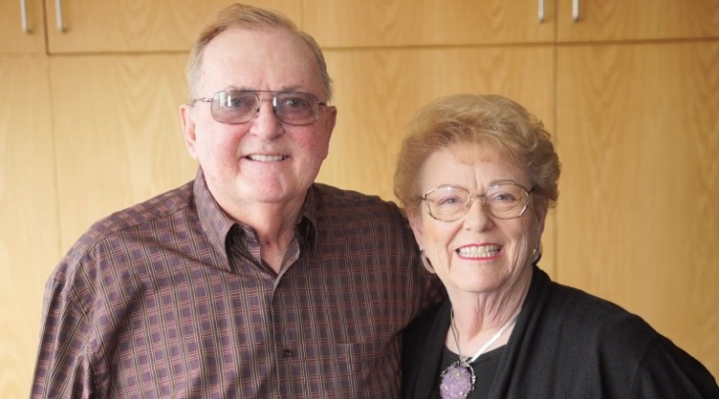

Connecting with

Post-Lung Transplant Patients

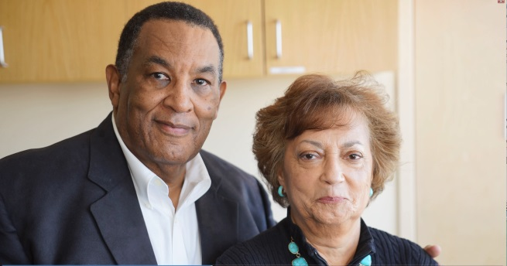While you are on the waitlist, or even before that, it would be good to speak with someone who has already had a lung transplant. UCSF offers monthly support groups, moderated by our social workers, that you can attend to meet and discuss your concerns with post-transplant patients. We encourage you to do this. We can also connect you with a post-transplant ‘mentor’ to talk with one-on-one. Ask your social worker or nurse coordinator for more details about this.

**In Case of Emergency,

Dial 911

VERY important to remember for while you are on the list: IF you have an emergency, DO NOT delay your care by calling our office to ask for instructions. If you need emergency care, dial 911 or go to your local emergency room RIGHT AWAY. Do NOT delay. Once you are safely in care, call our office, or have your family call, to update us on where you are and what happened. DO NOT rely on the hospital or doctor’s office to call us.

You MUST call to notify us for two reasons: 1) so that we update our call team and let them know your status as it relates to accepting donor offers on your behalf, and 2) so that we can consider transferring you to UCSF for care.

Once we get a message from you that you are at a local hospital, we will call and review your status with the doctors taking care of you. If it seems like they’re on the right track and you are getting better, we will likely just follow along via phone to see how you’re doing every few days, then see you in clinic after you have been released from the hospital. This would be the case with something like an infection being treated with IV antibiotics or a broken bone. BUT, if it seems like you have an exacerbation or something going on where it might benefit you to be at UCSF, we will request that they transfer you to us and start making arrangements for that. This is VERY important: DO NOT delay in seeking emergency care when/if you need it, but DO remember to have someone update us AS SOON AS YOU ARE SAFE by calling our 24 hour phone number **(415) 353-4145**.

No Guarantee of Transplant…



It’s important to know that being listed for transplant is not a ‘guarantee’ of actually getting a transplant. It would certainly be our intention, but sometimes plans change. IF you develop a new medical issue, if you gain too much weight or lose too much weight, or if you become too debilitated, your name will be removed from the waitlist…and there IS such a thing as being too sick for transplant. This also applies to psychosocial reasons. For example, IF your caregiver support plan, transportation, or insurance, or medical compliance/adherence becomes inadequate for the transplant process, your listing may be jeopardized. If this happens, the team will notify you of the issue and of your delisting.

_________________________________________________________

Getting “THE CALL”

*Now, let’s talk about actually getting ‘THE call’ to come in for transplant…*

BEFORE we call you, our surgeon has already reviewed all of the donor’s information and determined that it is indeed a good donor for you. This means that the donor’s history, the imaging (like CT scan or chest X ray), the lung function and all of the blood testing has been reviewed. We have made sure that the lungs are approximately the right size and that they are a compatible blood type to yours. By the time we call you, we have (usually) already accepted the offer on your behalf. Because of this, and because the arrangements for retrieving the lungs have already begun, it is ESSENTIAL that you be prepared to come at a moment’s notice. We do not want to risk losing good lungs due to delays. To this end, you should start preparing for your trip into San Francisco.

Make sure that you have arrangements in advance for someone to drive you in and make sure that they can get to you right away (or you get to them) when the call comes in. Again, no delays.

*When we call…*

* 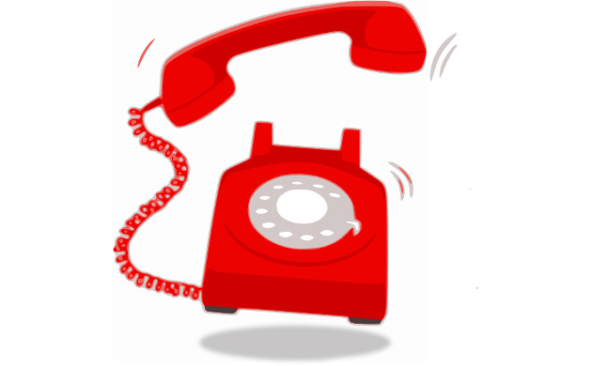**We will ask if you have any new symptoms.** Hopefully you will have called to report these in advance, but if you DO have something new going on, please tell the coordinator when they call you. We will find out when you get to the hospital anyway, and you may just save yourself an unnecessary trip to San Francisco. If you have active signs of infection, this may not be the best time for transplant.
* **We will tell you that we think we have the right lungs (or lung) for you.** At this point, the offer has been thoroughly reviewed and SO FAR, everything looks good. HOWEVER, at the time we call you in, the donor lungs have not come out of the donor’s body yet. So, there is a chance that something may later turn up that tells us that the donor lungs are not as good as we thought. If this happens, we will send you home without the lungs and call you when we have the next good offer. There is no sense starting this, already complicated, process with lungs that are not good.
* **We will tell you to leave your valuables at home.** Please take off any jewelry and leave it at home, even wedding rings. And any electronics you may bring, like cell phones or laptops, please make sure to give to your family for safe keeping while at the hospital.
* **We will typically tell you not to have anything more to eat or drink.** This is to avoid aspiration into the new lungs while you are lying flat for the surgery.
* **We will tell you to bring your medications or a list of your medications that includes the doses and times.** IF you have any medication that is difficult to walk into a pharmacy to get, please DO bring this one with you just in case you need a dose and we don’t have it in stock. The hospital has a rule that patients cannot have their own medications at the bedside, so, to avoid this issue, we will inventory the meds and then give them to your family/friends to keep safe.
* **We will remind you to bring in your insurance card and a photo ID** for getting you checked in at the admissions office.
* **IMPORTANTLY, you will need to BRING ENOUGH OXYGEN TO GET TO UCSF AND ENOUGH TO GET HOME,** just in case the lungs aren’t good enough. You should prepare yourself for this possibility because it happens about one out of every three or four times we call someone in, so indeed it could happen to you. And sometimes, more than once.

Packing

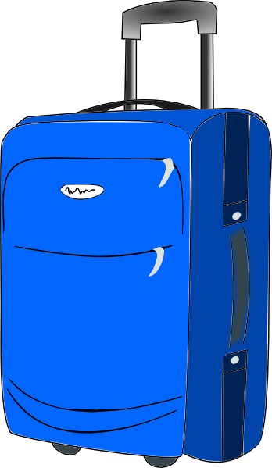

*In terms of packing, you may want to start thinking about it in three phases…*

1. **What do I need to grab QUICKLY just to get to the hospital?**

This would be the things we just mentioned, insurance card, ID, meds, and LOTS of oxygen. You may also want to put a list of things to grab at the last second on your fridge so that you’re not delayed. Things like your phone charger and your phone contact list that you can’t pack in advance, but will want to bring.

1. **What will I want a few days after surgery when I start moving around?**

For the first few days after you wake up, you won’t be very alert to these things, but after three or four days, you may want to have your own toothbrush, your own brand of toothpaste, your own robe or your own slippers. We DO have everything you need at the hospital, but if your own personal care items make you feel better, you can have someone bring things like this while you are working on your recovery. You will not need to bring clothes at this point, because we will want you to stay in hospital gowns until almost time for discharge.

1. **What will I need when I’m discharged from the hospital and moving to my San Francisco ‘home’?**

You definitely need a thermometer, a blood pressure cuff that measures heart rate too and a scale to weigh yourself. We will have you take your own vital signs a couple times per day to monitor yourself for signs of rejection or infection. You may want also to start thinking about what kinds of clothes to pack. We recommend that you pack shirts that button or zip in the front because you may have restrictions on raising your arms above your head while you recover. Women may want to think about getting comfortable sports bras that close in the front, not that you pull over your head. Plan to bring comfortable pants and good walking shoes because you’ll need them to get out and use those nice, new lungs. You may also want to consider bringing a wedge for your bed so that your head always stays higher than your stomach while you sleep. This is to avoid aspiration into the lungs.

Transplant Day

Admission

When we call you in, we will tell you to check in at the Admissions Office on the first floor of the main hospital at 505 Parnassus Avenue, San Francisco. We will have called ahead to let them know why you are coming and request that they start getting a room ready for you. When you are admitted urgently like this, it’s hard to tell where you will be roomed, but as soon as you are checked in, the admissions staff will send you to your room and we will find you there to get started with this process. Surgery usually happens within 12 hours of when you are called in, however, there may be unexpected delays. We will do our best to keep you informed of these. After you’re in the room, the nurse will start an IV, get some blood drawn, and get you settled in. Doctors and other staff will come to interview you and get the surgical consent signed.

Waiting Time



*Then we wait….*

After you are here and in the hospital room, there is typically a period of waiting. You may want to bring something to keep your mind busy while you wait (like a crossword puzzle or a book).

We need to get you here and checked out as quickly as possible so that we can then focus our attention on the donor surgery and preparations. There are SO many arrangements involved in getting the organ recovery planned. This period of time is usually about getting recovery teams (that may be coming from several different facilities to retrieve the liver, kidneys, heart, etcetera all to the donor hospital). So, there may be delays in YOUR surgery that are due to some of these donor logistics and have nothing to do with you or the donor’s quality.

Possible Complications

*There are some situations that may add complication to the call-in and surgery waiting period….*

* **Increased (or High Risk) Donors.** For Increased Risk Donors, we will normally call you to discuss the increased risk donor classification even before we accept the offer on your behalf. Please see our video clip on Increased Risk Donors as they deserve further explanation.
* **DCD Donors.** A DCD (or Deceased-by-Cardiac-Death) donor may also add some complexity to transplant surgery. This is a situation where the donor’s heart stops after life support has been withdrawn as dictated by the donor’s family. The surgery then begins for organ donation. In this situation, if there is an extended period of time after support is withdrawn and before the heart stops, the organs may not be suitable for transplant. In this situation, you will be told there is an increased likelihood (over a standard donor situation) that you could be sent home without transplant.

“Back-up” Recipient

There is a possibility for you to be called in as a ‘Back-Up’ recipient for a donor offer. This means that we have accepted the lungs for a person above you on the waitlist, but that there is some issue about that donor-recipient match that may not work out.

*Two instances come to mind, but neither comes up often…*

* **Antibodies.** The first would be when the intended recipient has some antibodies that may be problematic with that specific donor. Crossmatch testing takes several hours and we may not have the time to complete the testing BEFORE we call in that recipient. We may not have time to call in another recipient AFTER the crossmatch is completed, for reasons of the donor OR timing and our recipient’s travel time to UCSF. In this case, we need to get both the primary and back-up recipient to the hospital while the testing is in progress. If the crossmatch testing looks good, the lungs will go to the intended recipient, but if the testing indicates that the recipient’s immune system would attack the lungs, we would give the lungs to the back-up recipient.
* **Nodules.** The other reason we may call in a back-up recipient, is if the intended recipient has pulmonary nodules that we think are benign based on imaging. We tell these recipients that, when they are called in for transplant, the nodule will be taken out in the operating room and sent to the lab for examination under the microscope. IF the nodule turns out to be cancer, the incision is closed up and that patient does NOT receive the transplant. At this point, we have to have the back-up recipient ready to go to the operating room right away, or else the lungs (which are usually on their way back from the donor hospital by now), will have longer ischemic times. We will let you know if you are being called in as a back-up recipient. Again, because of timing, we cannot wait to get you on the road to the hospital until we have all the information back. If you are called in as a back-up recipient and the lungs go to the primary recipient, we will send you home and try again when we have the next good offer for you.

Single Lung or Bilateral Lungs

As a reminder, we can transplant either a single lung or bilateral lungs (meaning both). You should be prepared to be called in for either one or two lungs, unless we have specifically told you otherwise. And of course, if you need a combined heart and lung transplant, we will have already discussed this too.

Surgery and Hospital Stay

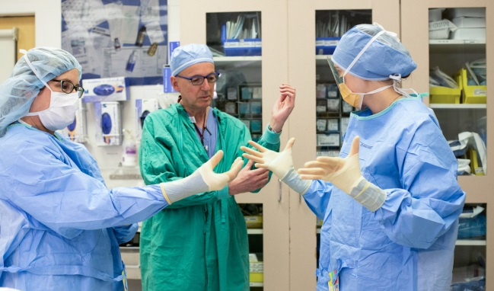*Here are some reminders about the surgery and your hospital stay…*

The anticipated length of lung transplant surgery is about 8 – 10 hours barring complications. The average hospital stay is about two weeks. Approximately the first week is spent in the Intensive Care Unit and the second will be on the medical/step down (less monitored) floor.

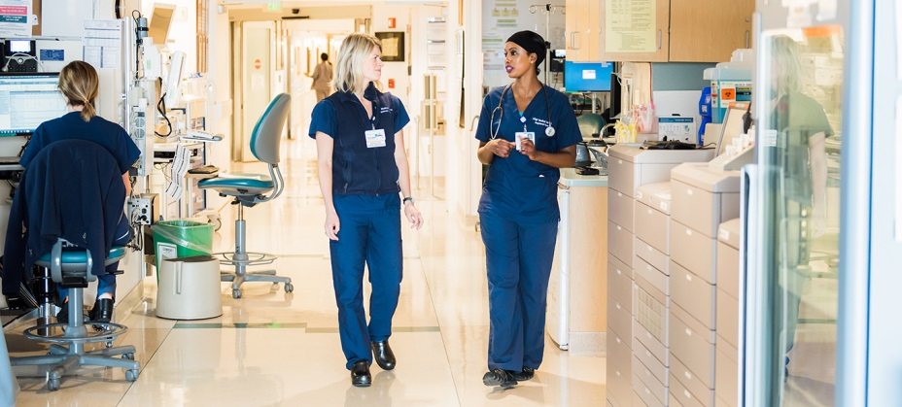*When you wake up in the ICU, you will have a lot of equipment attached that you did not have when you went to sleep…*

* **Breathing Tube/Ventilator.**You WILL have the breathing tube in your mouth, connected to the ventilator by tubing. We wake EVERYONE up like this so that we can take some measurements of how well the lungs are working BEFORE we take the tube out. It’s good for you to know this in advance so that you don’t fret that something went wrong when you wake up after the surgery and are all confused by the drugs. The tube typically comes out within a day or so after surgery. Of course, if there are issues, we may need to leave it in longer to be safe.
* **Wrist Restraint.** Because it’s normal to wake up, see or feel the tube in your mouth and reach to take it out, we will have your hands tied down with soft restraints so that you don’t accidentally pull out the breathing tube. These will come off when the tube comes out or when we’re sure that you are fully oriented.
* **Wound Dressing.** You will have the incision across your chest (for two lungs) or around your side (for one) which will be covered by a superficial dressing to catch drainage for the first day or so. The outside of the incision is normally closed with surgical glue and on the inside, there will be stitches which dissolve over time. If the surgeon had to cut across the sternum (or breast bone) to get far enough into the chest to implant the lungs, you will have a wire inside to stabilize the bone and cartilage while it heals. This wire will remain even after you have healed.
* **Chest Tubes.** You will have 2, 3, or 4 chest tubes below the incision line. These are tubes about the size of your finger. They are used to get drainage out to bedside containers to minimize the risk of a pocket for infection. These come out once the drainage has slowed or stopped.
* **Catheters.** You will have a catheter in your bladder to collect urine and a catheter in your back to help with pain management. These will come out once you have been transitioned to oral pain medications.
* **Feeding Tubes.** For patients with scleroderma or other esophageal issues, you may need a temporary or permanent feeding tube placed in order to minimize your risk for soiling the new lungs.
* **Swollen Face/Arms.** You will want to prepare your family for seeing you with all the equipment around when they first see you after surgery. Because of all the fluids you are given during surgery and perhaps because of the position you are in on the operating table, your face, hands and arms may appear quite swollen to your family and friends. This is only temporary. The fluid will be reabsorbed as you get up and move around.

We will be getting you up from bed VERY shortly after the surgery and at the time you may consider it just plain meanness on our part. But, we’re really trying to minimize your complications. So, be prepared to get out of bed, and work REALLY hard on your rehabilitation right from the start. As the equipment gets less and less you will be getting more mobile, so be prepared to get walking!

Other Reminders

*A few more reminders…*

* **Emotional change.** Because of the VERY high dose steroids that we use to knock down your immune system right from the time of the surgery AND because of sleep deprivation from all the bells and beeping, you may have some changes in your emotions. You may feel more ‘fragile’ than usual, maybe angry, perhaps paranoid, anxious or depressed.
* **Hallucinations.** You may also experience some hallucinations. It’s important that you (and your family) know that these issues are only temporary and will resolve as the doses of the steroids go down AND you get more regular sleep.
* **Education Sessions.** During the second week, after you’ve been moved out of ICU to the floor, is when we start teaching you and your caregivers more about these new lungs. Our nurse practitioners, coordinators and pharmacists will arrange for times to meet with you and your support team to learn about your medications and how to care for yourself after transplant. PLEASE give your support team advance notice that they will need to be at the hospital for these teaching sessions and we would VERYMUCH appreciate their flexibility in scheduling when the time comes. We will ask that they review information in advance and come prepared to discuss their questions and concerns.
* **Local recovery.** You will need to stay within a half-hour of UCSF with your care person 24 hours a day and 7 days a week for the first 6 weeks starting at hospital discharge (not starting at the date of surgery). You will want to start making at least some tentative plans for where you will stay for your local recovery even before you go onto the waitlist. This may involve visiting local hotels to see what their accommodations look like and it will usually involve raising or saving some funds in order to pay for it.

Be prepared to work hard, follow instructions and ask questions when something doesn’t seem quite right. We’re counting on you to do your part and we’ll be here to help you by doing ours.

Contact Us

If you have questions, please contact your coordinator so that we can help clarify any concerns you may have. You may contact our office at **(415) 353-4145** for questions, comments or more information. You may also find more information at **LungTransplantEducation.UCSF.edu**.