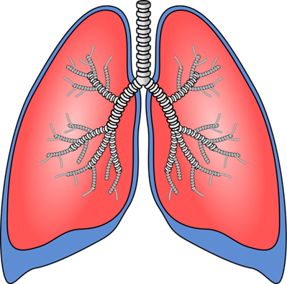

Lung Transplant
Social Work

Introduction
As the clinical social workers for the lung transplant team at UCSF, we are here to help you during the entire transplant process to provide support, counseling, and education. We also work closely with your caregivers, who are a very important part of your transplant journey. We are able to follow our patients before, during and after transplant.
We focus on the psychological and practical support needed by our patients and their caregivers in dealing with the stress caused by this transplant journey. We work on many of the non-medical aspects of transplant, “from forms to feelings.”
We run a monthly support group for patients and their caregivers so you can meet other pre- and post-lung transplant patients. We invite guest speakers from UCSF so you can continue to learn more about transplant. We can also connect you to some community resources that may help you before and after your surgery.
We will now go over the role of the UCSF social worker during the transplant process and some of the common emotions that our patients deal with at different times during the transplant process.

Evaluation

Once the medical team decides to move forward with your evaluation, you will be scheduled to meet with a social worker.
The purpose of this visit is to get to know you and to give you more education about the practical and the emotional pieces of transplant. This will include what you need to prepare for transplant (for example, finding caregivers, doing fundraising, working on coping skills), and talking about lifestyle changes that come after surgery.
These questions are not meant to exclude you from transplant consideration, but to help figure out what you will need to have the most successful outcome.
Gathering Information
We will talk with you about your current life, including your housing, your support system, your current level of activity, and any financial concerns you may have. We will discuss the six-week post-hospital recovery plan. This includes your caregiver plan and the need for temporary relocation to within 30 minutes of UCSF.
We will also go over your current and past mental health and drug and alcohol history. We will talk about your way of coping with stress and your overall motivation and feelings about lung transplant.
If you have family members or friends who rely on your care, we will talk about who will look after them in your absence. Finally, if you have furry friends at home, they will need a plan too.
Benefits
We will review any benefits we think you might be eligible for, like state disability, private disability, Family Medical Leave Act benefits and a special program for caregivers in California called Paid Family Leave. Many people are concerned about finances, so we will talk about how to prepare for transplant expenses that are not covered by insurance.
We will ask you and your caregiver if you have any special learning needs that you would like us to know about. This may include issues with reading, hearing or seeing, a need for an interpreter for yourself or family members, or even input from you about the best way you learn new things.
Advance Directives
We encourage all patients to complete an Advance Health Care Directive. This form lets us know your wishes for what to do with your care if you are not able to decide for yourself. It also lets you identify someone to make decisions for you if you cannot do this for yourself. UCSF has a kit for this online, if you don’t already have one.
Wrapping Up the First Meeting
At the end of this first meeting, we will talk with you about any issues that will need to be addressed for you to be a candidate for transplant and to have the best outcome. This may include identifying people to care for you, financial preparation, ways to increase your coping skills, or getting extra education or support.

Readiness for Transplant
Your overall readiness for transplant is based on your medical and surgical evaluations and all the areas we discuss with you. The transplant team looks at all these factors to determine if transplant is the right treatment for you at this time.

Coping with Waiting
As you go through the evaluation process and approach your transplant window, you may be getting more ill and may be needing more help from family, friends or other caregivers. This can be a challenging time, and it is common to have feelings of grief and sadness related to your change in health. In particular, you may be grieving the loss of the old “healthy you” and feeling unsure of what has to come.
All of these changes can affect your sense of self, your relationships with your family, your financial standing and how you see your future. There can also be “silver linings” during this time which include more appreciation of life and a desire to value each day.
Ways to Cope
There are ways to cope during this waiting period:
- Getting regular exercise
- Getting enough sleep
- Schedule a few pleasant things to do each day
- Talking with family, friends and other transplant patients

We know that many aspects of transplant care are out of your control, and suggest that you try to focus on what you can control, like being active. This will better prepare you for a successful recovery.

If you notice that symptoms of depression or anxiety are lasting more than a week or two and are changing the way you live, please let your social worker or your primary care doctor know so that we can work with you to get the support that you need.
Support Group and Mentors
Please join us at the monthly Lung Transplant Support Group meeting, which is held on the third Thursday of every month at 1:00 pm on Zoom. Many people find it helpful to ask questions of the post-transplant patients.
We can match you individually with a post-transplant patient so that you can talk one-on-one. For example, if a woman with younger children is worried about managing family life during transplant, we may be able to match her with a post-transplant patient who also had younger children at the time.

Hospitalization at the Time of Transplant

The hospital experience varies widely. This includes the amount of time people are in the hospital before lungs come available and how long they stay after surgery.

Some people wait weeks or even months in the hospital before transplant, while others get the call from home and are in surgery later that day.

After transplant, some people are here for two weeks with few complications, while others stay in UCSF weeks or even months due to a number of complications.
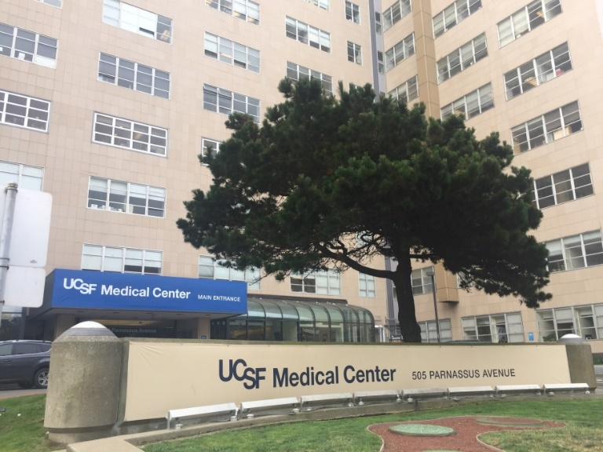
Coping skills from home are also useful in the hospital – staying active, keeping in touch with family and friends, and finding things to enjoy, like reading, drawing or watching favorite TV shows.

During your hospital stay, your social worker will continue to check in with you and your caregivers to ask how you are doing and to follow-up on any needs you might have.

How Social Work Can Help

Many things we help with are geared at helping you prepare for your post-hospital phase:

- Helping you understand different benefit programs, like disability or paid family leave
- Filling in forms for your employer (if you are working) or for your caregiver
- Submitting grant applications
- Linking you to community services

We will be going over your six -week local lodging plan with your caregiver, and if needed, giving ideas for places to stay. UCSF has a guesthouse about eight blocks away where patients and their caregivers can stay, and we make these referrals for you.
We will also be checking in with you about how you are coping with the surgery, your hospital stay, your new medical regimen, and all the lifestyle changes to come.
Transplant is a life-changing event for both you and your loved ones, and we expect that you will have some ups and downs.

Life after Transplant

You already know that some of the medicines that you get after transplant can cause intense feelings or mood swings. Even without these medications, we want you to know that it is normal to have strong feelings after transplant – from joy at finally getting new lungs and hope for a better quality of life, to sadness at knowing that someone died and their lungs were given to you.
Setbacks are Normal
It is also normal to have some setbacks during your recovery – some are minor and can be fixed with a few changes, and some that may require another hospital stay. It is very rare for someone to have a perfectly smooth recovery without some bumps along the way!

Some of the Challenges
Some of these normal “downs” after transplant can include feeling overwhelmed by the after care, worries about being a burden on caregivers, and guilt that maybe you’re not always leading an amazing life every day.
Please be kind to yourself – you’ve survived having a life-threatening illness and now you’ve had life-changing surgery. Finding your new normal will take time. This is important for us to say again - If you find that you feel depressed or anxious every day and it’s changing the way you live your life, please contact your social worker or another team member so that we can help you.
Your New Normal

Many of our patients tell us that after transplant, they take joy in small things, like being able to tie their own shoes without getting short of breath or going to the store without having to carry oxygen tanks. They share that they treasure being able to spend better quality time with family or other loved ones.
Your experience of how your life will change is unique to you, and this will include your overall function, your ability to work, how long your recovery takes, and perhaps even a shift in relationships with family or friends.
What our patients often share is that is that having a donor’s family offer them the ‘gift of life’ is one of the most meaningful experiences they will ever have.

Thanking Your Donor Family

If you want to write a letter to your donor family, your social worker can assist you with this. There is no set time about how long you should wait to do this, but we recommend that you first focus on your own recovery. After all, one of the best ways to thank your donor is to take good care of the lung or lungs you received.
It is a personal decision on whether you choose to write to your donor’s family or not. If you decide to, writing a letter can be a very good time to reflect on your transplant and how your life has changed due to the gift of organ donation.
It is important to know that you may (or may not) hear back from the donor’s family. If you choose to write, it should be to express condolence for their loss and gratitude for their gift. For many donor families, the process of organ donation helped bring meaning and a measure of hope to a very difficult time for them.

Contact Us

We appreciate the time you have spent learning about lung transplant social work and some of the non-medical pieces of transplant. We are here for you and your caregivers to support you during this time. Please contact our office at (415) 353-4145 with any questions or issues.

